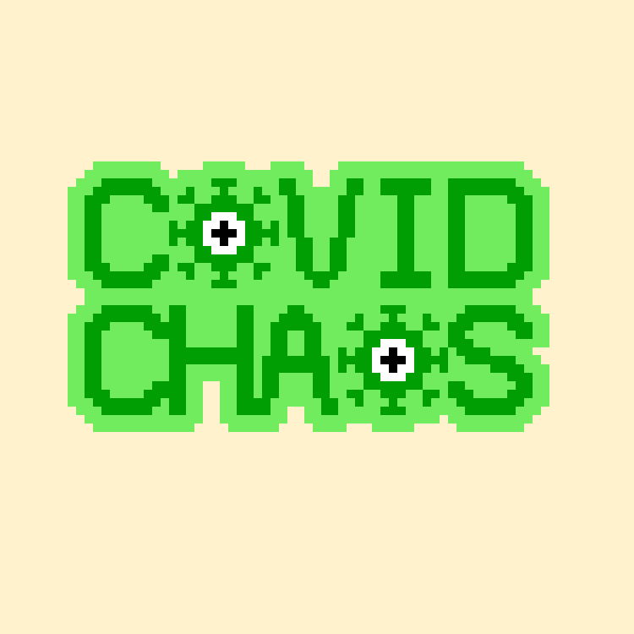

Overview:

Covid Chaos is 32bit 2D pixel art game that combines the play styles of both platforming and wave defence games. It is a light-hearted and satirical take on the pandemic and subsequent series of lockdowns that struck the world in 2020-21. The game centres on a few elements of this period; the chaotic nature of people buying excessive amounts of supplies and everyday necessities, the waves of lockdown being lifted and then reinstated after rising infections rates and the discovery of new strains which had an effect on people’s abilities to leave home for extended periods of time. The game will make use of the popular game engine Unity 2019.4.18f1, due its robust nature and user-friendly design, allowing for an effective and smooth development.

Under pressure:

The main object of the game is to quite simply, survive. Various aspects of game play will reflect and mimic the events that took place globally. Much like the minimalist business hours of shops and the wild droves of people that flooded them, the short time limit and roaming NPC’s when platform will put the player under pressure to always keep on the move. The NPC’s behaviour will also have the playing thinking on their feet, as they can take your items and much as you can theirs. Due to the large influx of hoard buying, most shops implemented purchase limits to items, there will be variations of the items a player can collect but, are limited to collecting ONE TYPE of variation only. This is where inventory management comes in as the player has to think about which variant they want as they all have different strengths and abilities as well as having a carry capacity limit.

Progress:

Covid Chaos has no linear progression like a traditional platformer does where there are multiple levels to beat, but instead success comes in the form of collecting items and using them to survive waves in stages with difficulty increases from larger hoards with new unique enemies added each time. This format encourages the player to rethink collection strategies each time they go through platforming, so they may have the optimal inventory set for the coming onslaught of foes. Both sections of the game take on two different areas of a large map; the platforming area is styled to resemble a shopping centre; the wave defence is set in the players home with the enemies coming from the front and back of the house.

The level of difficulty for the waves increases in set amounts of 5 as to not shock the player with dramatic spikes, and for smoother progression through stages, with each stage consisting of 3 waves. As the player makes their way through the stages new enemies and items with appears during the platforming and wave defence sections. The enemies will each have a unique ability and buffs so that the challenge is more than just more enemies.

The new items offered to the player can either help with platforming in the forms of temporary abilities and buffs, or as inventory items with unique uses and added strength.

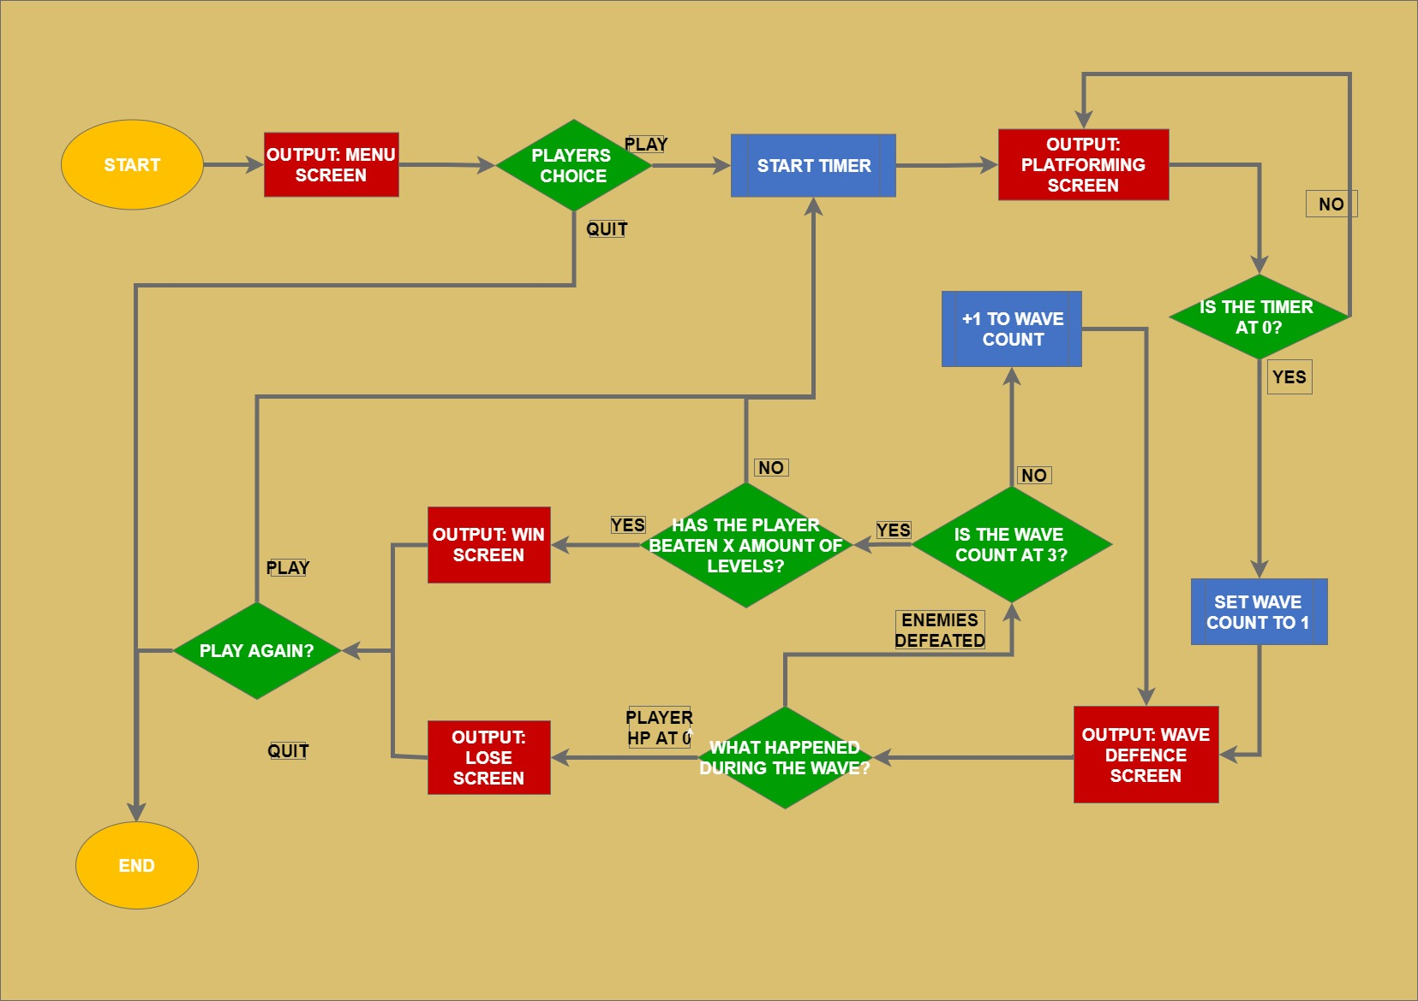

Get moving:

The controls scheme and layouts in both stages are simple and remain the same throughout the game which is crucial to its’ fast passed nature and it’s intended platform, mobile devices. The player needs full control of the character without having to worry about differing control schemes, so that they only need to worry about the items and enemies and can enjoy the game to the fullest.

The game consists of the traditional directional and control pad, with bonus item and menu buttons located in the top left & right corners of the screen. This layout style prevents the screen being cluttered by the UI by having in its’ own area near the players hands, not only that, but it is also a universally used setup in terms of both console and mobile platforms, which has stood the test of time and has remained relatively unchanged for decades.

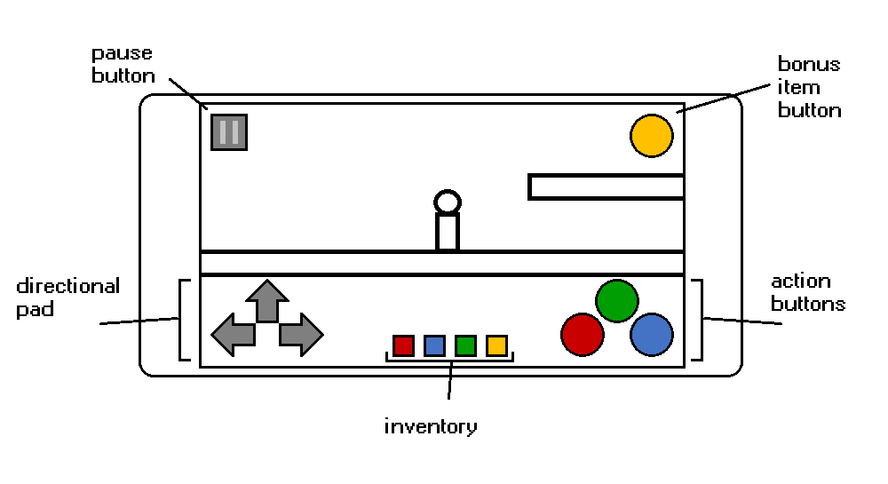

Items:

Items are an essential part of the gameplay mechanics, for both platforming and wave defence. Items collected for buffs in the platforming can only be picked up and used once per round, items collected for wave defence can be picked up multiple times but will have a limit as to how much of that item the player may carry.

|  |  |
| --- | --- |
| **Platforming buffs** | |
|  | **Hoover: temporary ability to take npc’s items for** |
|  | **Rucksack: prevent npc’s from taking your items for short period of time** |
|  | **Energy drink: speed boost to player** |

Even though there are 3 different items per category, the item may only collect 1 item type from each category. The player can choose however to change what they are collection, and the latest item they choose will replace what they currently possess. In doing so the item count reset back to one, so the player must restock their inventory with the new item.

|  |  |
| --- | --- |
| **Attack: all attacks are projectiles with varying effects** | |
|  | **Hand sanitiser: projectile that kills 1 enemy per shot** |
|  | **Cold & flu tablets: similar to the hand but with added splash damage** |
|  | **Anit-biotics: projectile that takes out multiple enemies.** |
| **Defence: Temporarily prevent damage taken from enemies** | |
|  | **Multivitamins: defence that reduces enemy damage by half** |
|  | **Gloves: creates a mini force-field around the player, keeping the enemy at bay** |
|  | **Mask: Creates a larger force-field the damages enemies who com into contact with it** |
| **Healing: restore health lost** | |
|  | **Food: heals 25% player HP** |
|  | **Plasters: heals 50% player HP** |
|  | **Full first aid kit: heals 100% player HP** |
| **Bonus: temporary buffs** | |
|  | **Vaccine: attack x2 (temporary)** |
|  | **Hazmat suit: defence x2 (temporary)** |

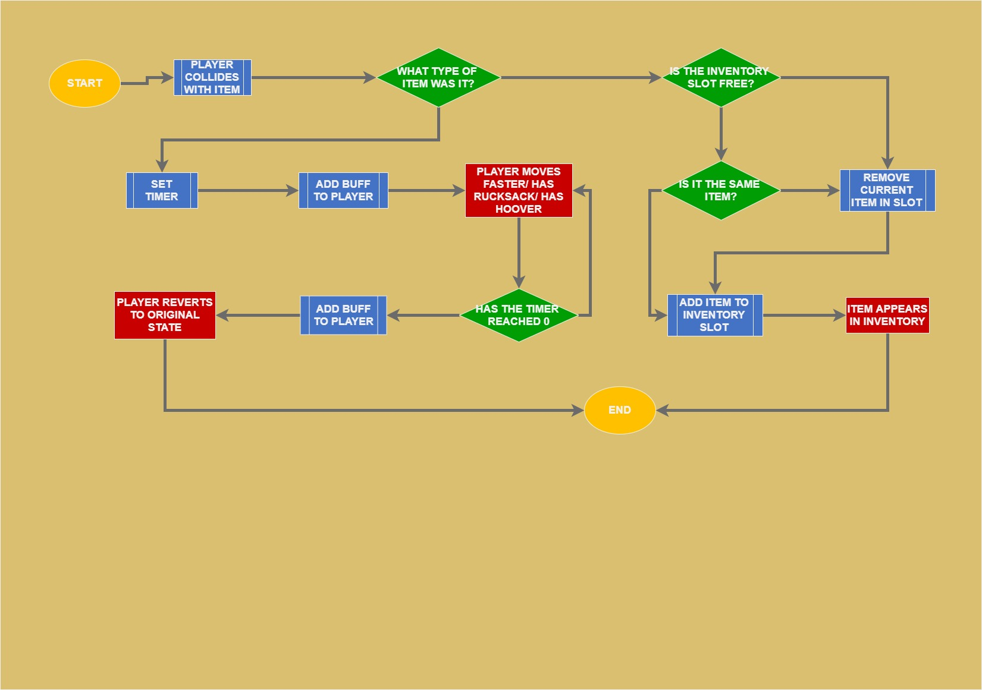

Enemies and NPCs:

The NPC’s added to this game are there to give the player some competition and drive in the fact that the player needs to remain on the go for the duration of the platforming section. Like the player, the NPC’s can collect items and used buffs, but only take 1 category of item.

NPC’s

|  |  |
| --- | --- |
|  | **Old lady: takes defence items** |
|  | **Karen: takes attack items** |
|  | **Fat man: take shealing items** |
|  | **Hipster: takes bonus’** |

The enemies of the game are only part of the wave defence for good reason, with its’ creating being inspired by the waves of lockdowns and infection rate spikes, coupled with the discovery and spread of various new strains.

Enemies

|  |  |
| --- | --- |
|  | **OG covid: nothing special about it** |
|  | **Indian variant: higher attack** |
|  | **Brazilian variant: higher defence** |
|  | **South** **African** **variant**: **moves** **faster** |

Art style:

The aesthetic direction chosen for this game wasn’t just so the game looks nice, but it was used on purpose for a number of reasons all relating to the atmosphere, the gameplay style, and inspirations surrounding the games creation.

Pixel art was an easy decision as it is almost synonymous with the platforming genre; simple and fun art style that matches the fun and often simple gameplay style. The use of pixel art can also allow for a clear Gameworld to be portrayed without the use of excessive graphic detail, this is especially useful when developing for mobile as there is limited screen space, which could cause some detail in the artwork to be lost in the aspect ratio.

The choice of using a bright and warm colour palette was selected to compliment and reflect the overall jovial atmosphere that the game creates. This idea waw influences by such games as Kirby, Super Mario and Sonic which all have a fun and playful nature to each of their worlds which tie in beautifully with their play styles too. However, it is also to add emphasis to the satirical nature of the game, as it is in complete contrast to the source material that was the rather miserable and testing times of the covid-19 global pandemic and many lockdowns that ensued.

The use of colour coordination is a big part of not just the aesthetics but the gameplay itself. The npc’s and the covid sprites have a colour scheme that is representative of their abilities and their inspirations. For example, the npcs’ in the platforming area are all assigned to collect only 1 type of item, and their clothes are the same colour as the items category. With the Covid sprites, they all contain colours of the flags from their respective inspirational countries. This will make It easier for the player to help recognise which variant(s) is on screen so that they can change their game play strategy accordingly.

Atmosphere & Sound

A traditional 8 & 16bit soundtrack and sound effects were adopted for this game, for the same reasons as the choice of Pixel art; it just works well and all three aspects have stood the test of time as one complete package. Both sections of the games will have their own background music as well as a range of sound effects with some being shared between the two.

Platforming: upbeat music that is a combination of shopping mall music and an 8bit style workout music reminiscent of 80’s workout videos that have a dance/pop drums and rhythm, that gets the head bopping. This is style will reflect the on-the-go nature of this section will also adding life to the shopping mall of the making it feel almost like a real place

Wave: Simple drum track with repetitive beat to mimic the way that the enemies will come in waves repeatedly, with the tempo speeding up with each wave that passes. This way the playing can really feel the pressure of both trying to survive and witness the clusters of enemies coming towards them the thought of being overwhelmed. This idea was inspired by space invaders as the tempo of the sounds also increase as the aliens move closer to the enemy throughout the game.

* + Player:
    - Jump - Boing/beep
    - Walking - tapping/footsteps
    - Attack - whooshing noise
    - Defence - cloth ruffling
    - Healing - sound of crunching or tape unravelling
    - Damage - grunt noise
    - Bonus - low to high scale beeping
  + npc:
    - Jump – lower pitch boing/beep than player
    - Walking – higher pitched tapping than player
    - Item stolen – grunt/disgruntled noise
  + enemy:
    - traveling - slimy/squelchy noise
    - Attack - slapping noise
    - Damage – splat noise
    - Death – low pitch roar

Platform

The game is aimed at two handheld platforms: android and iOS, as they are becoming a much larger part of gaming world then in previous years. Bosting not just a large audience but also a platform is more widespread than others as the majority of people across the world have a mobile device nowadays. The two platforms are currently more than capable of providing support for games, due to their app stores pre-installed on every device where anyone can download almost any kind of app they choose, as well as the software development kits available on programs such as Unity and Unreal engine.

When developing games for mobile devices, there are some things to consider, which are often unnecessary for console and PC. The controls, the UI, notifications from other apps & phone calls. Phone calls and leaving the app, can be easily managed, but simply putting the game in a paused state until the user returns to the app and un-pauses it. T

Milestone schedule

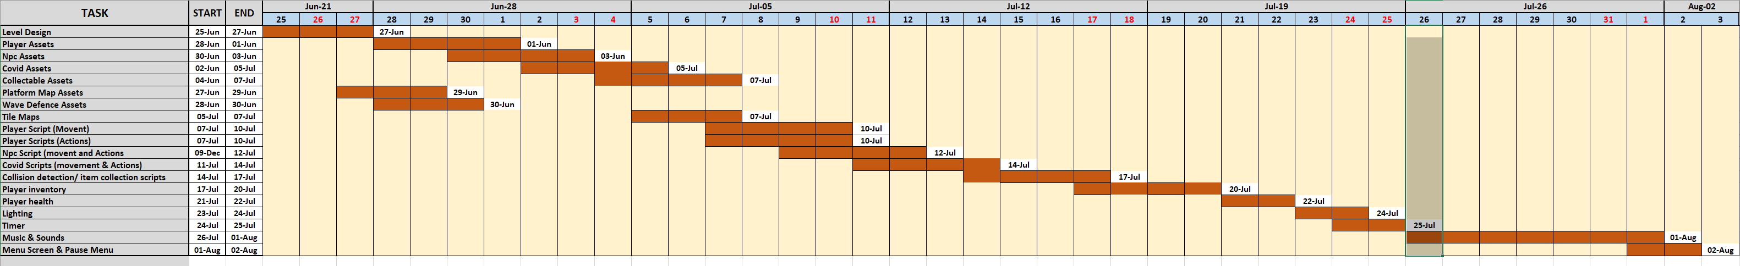

Bibliography & References

Saultoons. (2021) The ultimate Pixel Art Tutorial. Source: [The Ultimate Pixel Art Tutorial - YouTube](The%20Ultimate%20Pixel%20Art%20Tutorial%20-%20YouTube)

Pixel Overlord (2021) Do’s and Don’ts of Pixel art! (Beginner Tutorial). Source: [Do's and Don'ts of Pixel art! (Beginner Tutorial) - Youtube](Do's%20and%20Don'ts%20of%20Pixel%20art!%20(Beginner%20Tutorial)%20-%20Youtube)

Brackeys. (2018)How to make a 2D Game in Unity. Source: [How to make a 2D Game in Unity - YouTube](https://www.youtube.com/watch?v=on9nwbZngyw&list=PLPV2KyIb3jR6TFcFuzI2bB7TMNIIBpKMQ&index=1&t=309s)

Brackeys. (2018)2D Movement in Unity(Tutorial). Source: [2D Movement in Unity (Tutorial) - YouTube](https://www.youtube.com/watch?v=dwcT-Dch0bA&list=PLPV2KyIb3jR6TFcFuzI2bB7TMNIIBpKMQ&index=2)

Brackeys. (2018)2D Animation in Unity(Tutorial). Source: [2D Animation in Unity (Tutorial) - YouTube](https://www.youtube.com/watch?v=hkaysu1Z-N8&list=PLPV2KyIb3jR6TFcFuzI2bB7TMNIIBpKMQ&index=3)

Brackeys. (2018)2D Shooting in Unity (Tutorial). Source: [2D Shooting in Unity (Tutorial) - Youtube](2D%20Shooting%20in%20Unity%20(Tutorial)%20-%20Youtube)

Brackeys. (2018)2D Camera in Unity(Cinemachine Tutorial). Source: [2D Camera in Unity (Cinemachine Tutorial) - YouTube](https://www.youtube.com/watch?v=2jTY11Am0Ig&list=PLPV2KyIb3jR6TFcFuzI2bB7TMNIIBpKMQ&index=4)

Brackeys. (2019)2D Lights in Unity! Source: [2D Lights in Unity! - YouTube](https://www.youtube.com/watch?v=nkgGyO9VG54&list=PLPV2KyIb3jR6TFcFuzI2bB7TMNIIBpKMQ&index=7)

Brackeys. (2017) START MENU in Unity. Source: [START MENU in Unity - YouTube](https://www.youtube.com/watch?v=zc8ac_qUXQY)

Jimmy Vegas. (2019) HOW TO CREATE A COUNT DOWN TIMER IN C# UNITY TUTORIAL. Source: [How To Create a Count Down Timer In C# Unity - YouTube](How%20To%20Create%20a%20Count%20Down%20Timer%20In%20C# Unity - YouTube)

Unit (game engine)

Source: [Unity Download](https://unity3d.com/get-unity/download)

Jsfxr (Sound effects). Source: <Jsfxr>

BeepBox (Soundtrack). Source: [BeepBox](https://www.beepbox.co/#8n31s0k0l00e08t2mm0a7g0fj07i0r1o3210T0v1L4ua7q3d6f8y4z1C0w0c1h0T5v1L4u50q1d5f8y1z6C1c0h0H-JJAArrqiih999T1v1L4uc6q1d4f8y1z9C0c0A6F1B2VgQ0507P7c62E0011T2v1L4u15q0d1f8y0z1C2w0b4h4h0000000h4g000000014h000000004h400000000p1hidCzNNkQvhV600000)

GraphicsGale (Game visuals)

Source: